How to use

1. Open chrome and navigate to success factors and log in.
2. Navigate to Career Opportunities

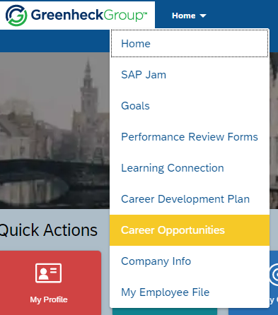

1. Select filters of jobs you to see then click search Jobs

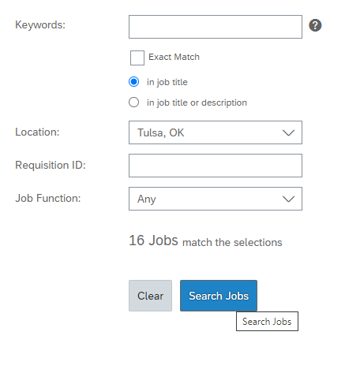

1. Change items per page to max amount

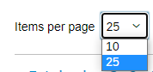

1. Right-click anywhere on the webpage and select Extract Links

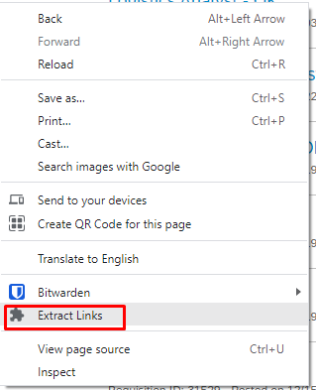

1. Choose where to download file. HTML file will contain filtered result with QR code that contain